Name: Cargile, Christopher
Student access ID: 10059306
Project: jEdit
Change Number: 3
Date: 10/17/2013
Team Number: 2

Change Request #3:”Search and mark all”
- Change Request:
The change request to incorporate, verbatim, was: “Under menu Search, add menu item “mark all”. Locate all matches and add markers to all of the lines.” The jEdit codebase that was checked out comes with a GUI look-and-feel that includes a standard file-menu with Search tab. Under the tab for ‘Search,’ menu options available and associated with ‘find’ included: find, find next, and find previous. If jEdit is compiled using a compatible version of the JDK, the GUI will either prompt the user to enter search criteria, of if text is selected in the jEdit window pane that is open, a search pane that pops up will be presented with the highlighted term pre-populated in the ‘Search For’ input-text container. It seems adequate the ‘Mark All’ option could be listed below the ‘Find’,’Find Next’, and ‘Find Previous’ menu options for ‘Search.’ The result of selecting the ‘mark all’ menu choice will be as evident to the user, after completing, as is any case where a marker is successfully/unsuccessfully placed: if the user opts to view markers (under the ‘Markers’ menu tab), each line that contains a match for the search criteria will be represented as ‘marked,’ there, and green shading will be present on the sidebar of the active, editable buffer. If placing a marker failed (as ie: no text was selected), the user will not witness any observable effect.
- Concept Location:
The concept location methodology that was used consisted of a combination of approaches, the primary of such was either to identify the relevant files via JRipples’ GREP text analysis means or usage of Eclipse’s Search: Files utility. JRipples’ GREP searching was useful to first identify a list of classes that contained main() methods, from which to begin inspecting jEdit. From there, hovering the classes to view the Java tooltip, then selecting ‘Open Declaration’ to inspect the classes’ code and/or methods (via e.g.: Eclipse’s Outline perspective) was used to search for the concept’s location by examining the calls from the main() program runners main/run method. As this examination did not reveal the concept location, nor reveal much detail about how the program actually was functioning I ran searches against the “marker”,”search”, and “mark” search keys and had better luck. Deducing that Actions.xml and jedit.props.xml likely need to be changed is probably more a matter of informed-intuition, based upon examining the format of those two files; by inspecting several parts of the controlling mechanisms inside jedit that seemed vital and realizing that these parts rely on data that retrieved by calls to getProperty()-type (system.getProperty(), et al) methods, it was evident the default property values would have impact on the system – and indeed they define most of the functional aspects of the GUI (layout-containers declarations and hardcoded property-file filenames) from initSystemProperties() and initResources() inside main().

Table 1. Classes visited during concept location.
# | File name | Tool used | Located? | Comments
1 | Buffer.java | JRipples GREP search | Yes; several seemingly pertinent methods were present | Unchanged - buffer seemed like a perfectly suitable match for implementing the CR at first, but further analysis revealed there might be an easier means.
2 | EditPane.java | JRipples GREP search/java text search | Yes; addMarker() seems highly likely to fit the need | Unchanged; the addMarker() method is distinct from the same method with a different signature implemented in Buffer.java
3 | SearchAndReplace.java | JRipples GREP search; Eclipse Search-> File | Yes | Changed
4 | propMgr.java | n/a; self-initiated search following investigation of jEdit.main() | No | Unchanged; this class was not identified by JRipples and was not relevant in anyway other than by assisting with the ‘glue’ b/n GUI and main()
5 | View.java | n/a; self-directed investigation led me to view.java | No | Unchanged; after finding that ‘view’ was a required parameter for many methods in SearchAndReplace, it seemed possibly relevant and able to indicate the inner mechanisms connectng the program and GUI.
6 | Actions.xml | Eclipse->Search utility | Yes | Changed
7 | Jedit.props.xml | Eclipse->Search utility | Yes | Changed
8(~ 15?) | (many files) | Various other methods, including java text search/java right-click option selection: References->Project, and self-initiated manual inspection | Essentially, no | Examining several non-utilized classes helped me identify a possible solution and better grasp the files at work in the BeanShell script-driven program environment in which jEdit runs.
- Impact Analysis:
Because the codebase is relatively large, it would seem reasonable to describe jEdit in terms of the modules(packages) it uses, but because the impact set associated with the change request is not overly cumbersome in terms of files modified nor diversity of the new functional requirements*, a small enough number of classes can be explained in terms of their purpose and bearing on the change requested.
SearchAndReplace.java is among the most significantly modified of files in the impact set. Its package includes a variety of search-related behavioral-drivers(methods/classes), but SearchAndReplace.java, itself, contains the find(...?) method(s). To implement the change request, it was determined find() must remain distinct from any method calls that change the marker locations. However, a slightly modified version of it, as easily overhauled to accommodate finding and marking a location in the same step –using findAll() and markAll() methods in unison, was able to effect the intended consequence. To achieve find-and-mark-all, we bound a ‘find-and-mark-all’ behavior to jEdit’s GUI that pre-determines all lines with matching search-string text matches, then place markers at each of them, sequentially, in markAll() proper, using the active file/buffer vs. all files in the active jedit fileset.
The specification does not indicate whether the feature needs to be capable of searching more than one buffer, so we limited our feature functionality to only searching the buffer/editpane having the current focus.
Multiple files were examined using JRipples’ GREP Analysis technique during the CL phase but fewer files needed examining during IA because the files were modified to incorporate functionality that was novel and therefore did not pose a threat to backwards compatibility. As an aid in examining the files during the CL phase, it would have seemed helpful if Eclipse were to have presented the ‘bookmark view’ as a default ‘View’ choice, so it could be discovered more easily by newcomers and if the Eclipse text editor made expanding/collapsing on non-method 0loops and {}’d code parts possible (like Notepad++ does / Eclipse did?). The ‘parse-args –style’ for-loop in jedit.main() is lengthy and would have been nice to collapse it, by sections, for quicker analysis of the rest of main() method.
*Perhaps per direction of RE recommend practices/agile development methods, the guidance in place ensured each ticket involves a maximum of only one type of change functionality, so describing the impact set becomes manageable.
Table 2. Classes visited during impact analysis.
# | Class name | Tool used | Impacted? | Comments
1 | SearchAndReplace.java | JRipples GREP text analysis | Yes | SearchAndReplace.find()contains behavior that can be almost replicated to produce the desired effect but needs to be enhanced, slightly.
2 | Actions.xml | Java Search -> File utility. | Yes | This file lists the behaviors associated with the user-input as ‘heard’ by the GUI listeners.
3 | jedit_gui.props.xml | Java Search -> File utilitiy | Yes | This file lists GUI configurations & declares data the GUI/controller binding mechanism will require.
4 | Buffer.java | From Java perspective, in SearchAndReplace, hovering addMarker() in Buffer, then clicking Open Declaration | Yes | Buffer contains addMarker() method that places markers or removes them, as relevant, at a given line. Removing is undesirable to the CR3 feature.
4 | MISCUtilities.java | n/a; inspected without much reason | No | File is insignificant to CR#3
5 | GUIUtilities.java | n/a; inspected without much reason | No | File is insignificant to CR#3
6 | jEdit.java | n/a; inspected without much reason | No | File is insignificant to CR#3
7 | Macros.java | n/a; inspected without much reason | No | File is insignificant to CR#3
8 | BeanShell.java | n/a; inspected without much reason | No | File is insignificant to CR#3

- Learning Process:
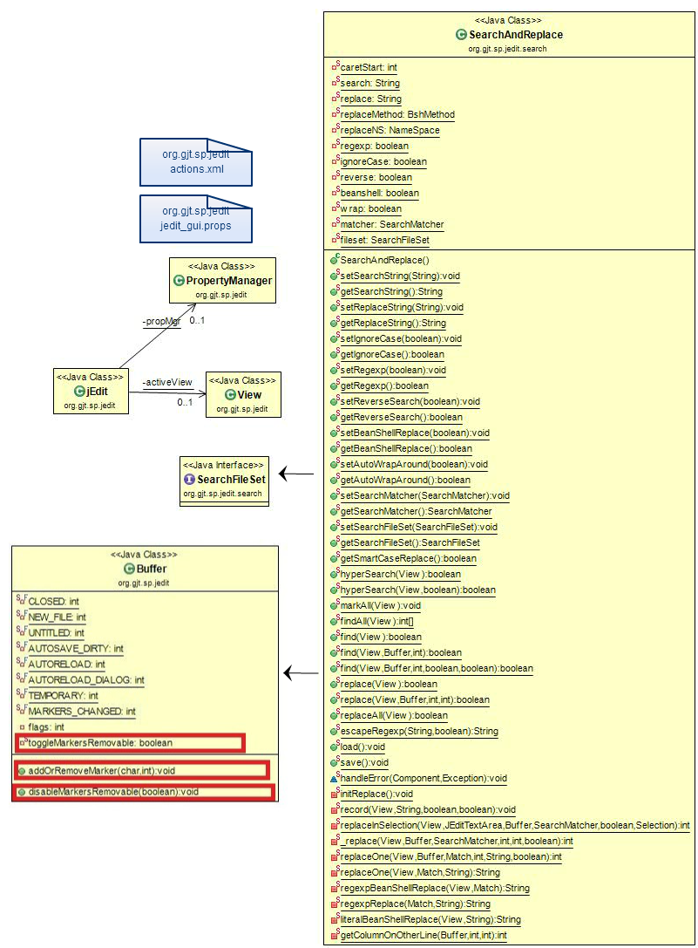
Figure 1 Impact set class diagram for Change Request#3 (by Chris Cargile)

- Description of the implementation:
There were in total 3 filetypes which required changes to implement CR#3 because of the nature of concerns separation employed in jEdit: where property settings are hardcoded in plaintext (.prop) files, actions are bound to handlers that are declared within a plugin API .xml file (which specifies beanshell scripts that will be associated with GUI actions), and functionality in the program we are concerned with is in .java files. A total of 4 physical files were changed: ‘jedit_gui.props’(1), ‘actions.xml’(2), ‘SearchAndReplace.java’(3), and ‘Buffer.java’(4). (1) allows creating & binding labels used in the GUI menus. (2) represents glue to bind the GUI labels (from .prop) to handlers mostly written in java. (3) is the recipient of the handle passed in by the .xml-binding/listener mechanism. When ‘mark all’ is selected in the GUI dropdown menu, SearchAndReplace.java gets a call to its <void>markAll(<T>View) method, which makes a call to <int[]> findAll() to obtain a list of all the locations (line#’s) in the current jEdit buffer (active textview instance) where the highlighted string of text recurs, then it places a marker at each of the line numbers that correspond, through individual calls to (4)’s addMarker() method. (4)’s addMarker() method previously made a call to addOrRemoveMarker(), which acted by placing a marker at the line or removing the marker if one previously existed, which needed to be changed. To implement this, a toggle method: disableMarkersRemovable() was added to allow disable the remove-at-will liberty afforded to Buffer.addMarker(). markAll() toggles the behavior for marker removal, to disable this capability before indirectly placing calls to addOrRemoveMarker(), which NOW changes markers per the toggle-attribute’s guidance.

For future relevance, a method object of (<Fileset>fileset) retrieves the current fileset, so in theory, the placement of markers across all buffers open in jEdit could be implemented, but this is not so realistically desirable nor within the scope of the feature request.

Functionally, it may be possible to obtain a null value from SearchAndReplace.getSearchFileSet(), which I did not witness happening ever, even when the .jedit filesystem directory had been removed before running the program and jEdit defaulted to an ‘Untitled-1” buffer instance. Still, while exceptions are caught and dismissed, or at worst logged to the console, to safeguard the user/system from unforeseen consequences ‘<String[]>files’ could be redundantly checked for != null to protect against null pointer exceptions. Comments could be more descriptive within markAll(), which calls methods specific to the jEdit codebase vs. programming language itself, so newcomers to the jEdit programming domain could better understand markAll()’s semantics, but comments are in line with those used by the main contributors.

Also concerning are that: there is a stray method object (<JEditTextArea>textarea) present in SearchAndReplace.findAll(); D. Rogina provided valid comments applicable to the code she reviewed vs. my previously committed code or the final code A. Baker reviewed for me.

- Sources: Hyperlinks to mentioned projects in bullet-point 3 indicate externally-referenced sources. In addition, I referred to beanshell.org in an attempt to better understand the glue that binds the actions(.xml) to the GUI(.props:for property settings, *.java:for views/controllers) and used exec(“explorer .”) from jEdit’s Utilities->Evaluate beanshell expression, successfully but do not fully understand the linkage between .xml and .java that the beanshell parser enables.

- Highlighted Source Code:

There were two different diff’s used by my teammates, as I accidentally pushed some changes to the SVN repository (Rev 10) – in an effort to tidy the code (from Rev.9) – that I did not intend to push. One teammate was able to complete his peer review using a subsequent, additional push since previous pushes had demonstrated necessary functionality, while the other teammate (D. Rogina) had already completed her peer review using changeset 10’s diff. I prefer if you could grade based on the functional code revision, but I understand grading should be fair for all students involved. In my defense, however, most of the functional aspects of her comments, were addressed adequately by the catch() clause used in my method approach, and the comment regarding <Fileset>fileset was addressed in my explanation (under enumerated item: 3. Impact Analysis) in the “CLIA”.doc submitted Oct 8.
